**ONLINE ARCHIVE SYSTEM OF ACCREDITATION FILES IN CAVITE STATE UNIVERSITY MAIN**

Undergraduate Thesis

Submitted to the faculty of

College of Engineering and Information Technology

Cavite State University

Indang, Cavite

In partial fulfillment

of the requirements for the degree

Bachelor of Science in Computer Science

**William Dave Agravante**

**Aeiou Drey Ahlenn L. Bingcan**

**Laica Dennise A. Miranda**

**Joel Alren M. Sidamon**

September 2022

**TABLE OF CONTENTS**

**Page**

**INTRODUCTION**

Project Context………………………………….………………………………...1

Objectives of the Study…………………………………………………………..3

Purpose and Description………………….…….....…………………………….4

Scope and Limitations of the Study..……..…...………………………………..6

Definition of Terms………………………………...……...………………………8

**REVIEW OF RELATED LITERATURE**………………………………………………...10

Technical Background……………………..…………………………………….10

Related Literature, Studies/Systems….……………………………………….11

Synthesis………………………………………….………………………………22

**METHODOLOGY**………………………………………………………………………...23

Design and Methodology………………..……………………………….……..23

Development and Testing………………...…………………………………….28

**REFERENCES**…………………………………………………………………………...32

**LIST OF FIGURES**

**Figure Page**

1 Implementation Plan ………………………….………………………………...24

2 Conceptual Framework for the Study……….………………………………...25

3 Systems Architecture …….………………………………………………….....27

**LIST OF TABLES**

**Table Page**

1 Table of Comparison of Related Studies……………………………………....20

2 System Requirements…………………………………………………………...25

3 ISO/IEC 9126 Testing Method………………………..……………...…………26

**LIST OF APPENDIX FIGURES**

**Figure Page**

1 Use Case Diagram of Instructor………………………………………………..34

2 Use Case Diagram of IDO Staff………….…………………………………….36

3 Use Case Diagram of Administrator…..……………..……………...………...38

**ONLINE ARCHIVE SYSTEM OF ACCREDITATION FILES IN CAVITE STATE UNIVERSITY MAIN**

William Dave Agravante

Aeiou Drey Ahlenn L. Bingcan

Laica Dennise A. Miranda

Joel Alren M. Sidamon

|  |
| --- |
| An undergraduate final thesis manuscript submitted to the faculty of the Department of Information Technology. College of Engineering and Information Technology, Cavite State University, Indang, Cavite in partial fulfillment of the requirements for the degree Bachelor of Science in Computer Science with Contribution No.________. Prepared under supervision of Mr. Russel Villacarlos. |

**INTRODUCTION**

# **Project Context**

Archiving documents acquires and maintains the institutional memory and records that were left by organizations such as universities, hospitals, and the government. It also ensures that the existence and quality of specific documents will remain for future uses. Throughout the history of archiving, documents have been stored in physical spaces such as archive rooms wherein they are sorted according to their types, alphabetical order, or importance. Although the documents are sorted, the number of files that are stored in archive rooms makes it difficult for people to retrieve them as it could require a lot of time and effort to browse through each document. Nowadays, technology has further improved the archiving of files using computer systems that act as digital storage instead of relying on physical storage where the number of files that can be stored is limited. These systems have also enabled people to search and retrieve documents easier, allowing them to use their time efficiently.

Archiving in Cavite State University has also become digital as it is easier to store and manage files with a system especially for organizations as big as universities. Document archiving plays a big role in the university as it is used not just to secure files but also to maintain the image of the university as even just mishandling of a single file could have major consequences, especially if the file is to be used for accreditation. Files such as accreditation documents are stored in a repository from the day they have been published and are to be discarded after five (5) years. According to one of the staff from the Institutional Development Organization (IDO), the unit responsible for accreditation of curricular offerings in Cavite State University, the process of accreditation goes through a survey of levels to comply with to be accredited for testing to ensure stakeholders and clients most especially students will be given a quality education. Files that are accredited are common files as well as college-based files.

Cavite State University has an Integrated Library System that acts as a digital library that does not only store e-books but also e-journals and theses for students and instructors to access. Another system that was developed is the Research IS which is mainly used as an online archive for manuscripts and research studies. In the latest study from Cavite State University by De Castro (2014), the researcher developed a centralized repository for the accreditation files to be used in the College of Engineering and Information Technology (CEIT), capable of processing documents via the computerized centralized process. As the time goes by, storing information or archiving important documents is very necessary and this must be efficient and helpful to both the users and the administrator. The problems that Cavite State University currently faces regarding archiving of documents are that (1) some documents are still stored in physical spaces, (2) files in Research IS are also in Integrated Library System thus making the data redundant, and (3) there is currently no archive system for files such as accreditation files, policies, memorandums, projects, plans, and charts that make them hard to be accessed by the university.

This paper aims to develop an archive system that shall help the institution have an organized collection of data which are not just research materials but also important university documents such as policies, memorandums, projects, plans, and charts used for accreditation. It shall also act as a reference for Cavite State University’s current archive system to improve by making an archive system that would store different kinds of documents used for accreditation. The system to be developed shall be beneficial to the IDO as it shall provide storage for the institution’s documents, specifically used for accreditation purposes.

# **Objectives of the Study**

The general objective of the proposed study is to develop a web-based archive system for the management of documents in Cavite State University that allows members of the institution, especially the IDO staff to access and keep track of the documents that are previously made and used for accreditation in the institution.

Specifically, the proposed study aims to:

1. Identify the requirements which are useful to develop an archive system that can help the members of the university, IDO staff, and administrators to store important documents such as policies, memorandums, projects, plans, and charts used for accreditation in one system and make sure it is easy to track.
2. Design a system that can solve most of the time constraints in filtering and searching for necessary documents in the institution.
3. Develop a system that can maintain the safety of the institution’s important files and avoid physical damage.
4. Develop a system that stores documents previously made to be used by people in accreditation for future references.
5. Develop a system that has proper management of its content.

# **Purpose and Description**

The proposed system shall be named as “CvSU Accreditation Archives”, a web-based information system that allows the people in Cavite State University such as the members of the university, IDO staff, and administrators to access digital forms of files such as policies, memorandums, projects, plans, charts, and lectures, to be used as instruments for accreditation. The proposed system shall be created with HTML and PHP, used to create web-based systems. With PHP, as the programming language used to create dynamic web pages for development of the proposed system. Lastly, the database management system (DBMS) to be used for the proposed system is MySQL as the said DBMS is the most widely used open-source database management system, along with the XAMPP as the proposed software’s web server. The system shall apply the use of cloud storage to ensure that the archived records would not be lost in case the system ever becomes compromised, as well as having another means of storage such as a removable disk as backup.

The system shall act as a digital storage for files specifically for documents made inside the institution. The system shall be able to categorize different kinds of documents that were made into a specific repository, whether it is for research such as policies, previous memorandums, projects, plans, and charts made in and for the institution. It shall give access only to the members of Cavite State University, IDO staff, and administrators working in the institution and would require the user to log in using their CvSU email address and password for them to gain access into the system. The documents stored in the system shall be accessible to the users including those who do not have a registered account to the archive system through sharing. These files can be shared through to other people through a direct link that would allow them to only view the specific file meant to be shared to them to reduce the risk of data leakage, having the access of said files limited to the specific email address. As a result, the university and the administrators will not be required to create new accounts since accreditors responsible for reviewing necessary documents are constantly changing from time to time depending on the kind of accreditation level. The proposed system shall have a search and filtering mechanism where the documents can easily be retrieved according to the search criteria. The search criteria would include various tags, years published, colleges, authors, as well as keywords that are related to specific documents. However, the system’s logs cannot be tampered with nor deleted for it is a way of keeping track of the actions inside the system. Since there are files such as policies, charts, and other accreditation files that need to be updated from time to time, the proposed system shall also indicate whether a file has become outdated and would need to be replaced with a recent one. Since the files will be updated from time to time, the duplication of files will be reduced and the system will prohibited the uploading of the same file and documents inside the database. It shall also be able to notify the users who uploaded the outdated files as well as the administrators of the system.

The proposed system will particularly benefit the institution as it ensures that the accreditation documents, policies, memorandums, projects, plans, charts, and proposed programs from colleges will be archived in a more secure storage system. The accreditation of programs and documents reflects the quality of education offered by the institution and can be used as an indicator that the standards set to be certified as having quality education have been met by the university. Through this, it will be further understood if there is a need for improvements and changes in the institution to reach a certain standard.

The proposed system shall become a way for the IDO to help them secure and access the previous documents to be used as accreditation files developed in Cavite State University. The proposed system shall be available to the members of the institution such as the students, faculty, and staff, and the study may also be used by the future researchers who would gain interest in conducting studies regarding the proposed system in hopes of improving the said system. The proposed system shall benefit people, particularly the Cavite State University IDO staff as well as the administrators as it shall aid them in keeping track of important accreditation documents in the institution as well as the future researchers who would like to develop a similar system or improve the proposed system.

**Scope and Limitations of the Study**

The system is a dynamic website that acts as an archive system for accreditation files in Cavite State University. The system shall implement the use of an online storage, particularly Google Drive and Microsoft OneDrive as storage, since Cavite State University has already been using these cloud storages in storing documents specially files handled by the IDO. It is made up of three modules: the account management module, document management module and log management module. The account management module will handle the accounts of all registered users on the system. The user is required to provide a valid CvSU email address belonging to the university personnel to verify if the specific person can access the system. The access will be limited only to the administrator as the accounts are confidential as it has the users’ essential information. This module also holds the lists of registered accounts in the system in accordance with the level of authorization of the account. Each classification of users’ accounts registered in the system has different dashboards. Members of the institution shall only have access to viewing and downloading of files in the system, an IDO staff have access to all files in the system with the ability to upload, update, and delete files excluding the system logs, and an administrator is authorized to locate any files along and has the ability to view the system logs.

Next is the document management module that will allow the user to access files in terms of viewing, uploading, downloading, and sharing of files. All classification of accounts registered in the system could view, upload, download, and share materials. Documents required for accreditation are requested from different offices of the university, some are from specific faculty members or officials/ personnel of the university then the IDO will validate the documents for accreditation. While accreditation documents are prepared per area that depends on the level and phase. The documents are prepared in ten areas: 1. VMGO (Vision, Mission and goal), 2. Faculty, 3. Curricular, 4. Support to students, 5. Research, 6. Extension and community involvement, 7. Library, 8. Physical Plan and facilities, 9. Laboratories and lastly 10. Administration. Although the proposed system is an archive system, it shall be capable of sharing specific documents to other people through direct links that would only allow access to particular people the links have been sent to. Since there are materials such as policies, charts, and accreditation files that need to be updated from time to time, the proposed system shall also indicate whether a file has become outdated and would need to be replaced with a recent one.

To ensure that the outdated documents are distinguished, the files will be uploaded in real-time. Specific files can also be shared to other people such as accreditors that do not have access to the system by direct links, wherein they shall only be able to view the files that are shared to them to secure other files in the system from being accessed by unauthorized people. It shall also be able to notify the users who uploaded the outdated files as well as the administrators of the system. The notification of outdated materials will be sent through the registered email of the uploader, the notification includes the date of the material uploaded and the current date which will avoid the confusion of the uploader. However, only the uploader could update, replace, and delete the uploaded document to avoid unauthorized tampering. The proposed system aims to provide secured administration of substantial files that passed the accreditation process through proper sorting in accordance with its purpose and file type.

Lastly, the log management module is responsible for the continuous process of collecting, parsing, storing, analyzing, and disposing of data that includes timestamps of the user. The system logs provide real-time activities of the user along with the user’s name, classification of the user, the user’s email address and its timeline of activities. The system’s logs cannot be tampered with nor deleted for it is a way of keeping track of the actions done by the users inside the system.

In view of the fact that the proposed study is used for the development of an online archiving system for Cavite State University, it is limited only to the institution’s IDO staff as they are the main beneficiaries of the study, members of Cavite State University, the accreditation agencies involved in the accreditation process of the institution, and the future researchers conducting similar studies in which the proposed study shall be able to be used as a guide and reference to follow.

# **Definition of Terms**

For clarity of meaning throughout the thesis, the following definitions are applicable:

**Web-based system.** The proposed system shall be created with HTML and PHP.

**Web-based archive system.** An online management system that manages documents to be proposed for Cavite State University.

**DBMS.** Abbreviation for Database Management System that will be use by the researcher for storing and retrieving users’ data.

**MySQL.** The open-source database management system that will be used by the researchers for the web development of the project.

**XAMPP.** The researchers’ proposed software’s web server.

**PHP or Hypertext Preprocessor.** This tool will be used for making the dynamic and interactive web pages of the proposed system. This will be embedded to HTML to manage dynamic content, design.

**REVIEW OF RELATED LITERATURE**

This chapter involves the technical background, diverse related literature and studies that take on different ideas and hypotheses related to the study, and the synthesis of the study. The related literature and studies are used as guides and inspiration for the researchers in establishing the study.

# **Technical Background**

Nowadays, people take better and smarter technology for granted every day. In every area, this advancement in technology brings out the brain power of people involved, providing effective structure and support in the interest of delivering better results. Lives of people became more efficient because of these innovations as they are made to improve the quality of life of their users.

The researchers will use *Hypertext Markup Language (HTML)* to develop the system designed for organizing, asserting, and securing documents made in the Cavite State University. HTML is designed to present text and graphics for creating attractive web pages by styling.

*Hypertext Preprocessor* *(PHP)* will be used for the system and serves as a server scripting language. This tool will be used for making the dynamic and interactive web pages of the proposed system. It is easy to use, free, and efficient, that will be embedded to HTML to manage dynamic content, design, and

The database management system (DBMS), *MySQL*, will be used in making the system because it is designed to manage a large amount of data and run operations on the desired data requested by the user. It will easily manage data and information on the proposed system’s database. MySQL is a part of the XAMPP package, an open-source application that allows the user to create a local web server such as WordPress on the computer.

*XAMPP*, which stands for Cross-Platform, Apache, MySQL, PHP, and Perl, makes transitioning from a local test server to a live server possible. It is simply a local host server that is used for websites before publishing.

*Adobe Photoshop CC 2020* will be used for developing graphic icons and other design elements to be applied to the system. It is a software used for creating graphic designs for different projects such as a website and can also be used to create digital art.

# **Related Literature**

**Paper documents to digital documents.** Technological advancements have affected the lives of people for the better, making it easier for them to accomplish their tasks fast and efficiently. This is also true for the development of documents such as those that are used whether in government, educational institutions, medical, business, or personal. Since the people entered the age when most of the things done in everyday life can be done through technology, this applies to creation of necessary documents that were before, could only be created by writing on paper, but are now possible to be produced digitally and afterwards, printed on paper, thus making documents accessible in the digital world as well as the physical.

In a study created by Ismail (2013) which tackled the previous online systems used for storing previously made theses from Malaysia, safety of the physical copies of theses is not guaranteed to last and be secured as physical files can be damaged or lost due to human error that would make it hard to be retrieved and make a copy of the original file. Not only theses made by students who have graduated from the institution, Caluza (2017) also stated that physical forms of documents are prone to being destroyed due to natural disasters unpredicted by human and the amount of storage required for each document would increase each time, along with the issues of misclassification, misplacement, and degradation of documents. Due to this, he developed an electronic document archive management system for personal documents of students, faculty and staff, and of the school administration.

In an article by Gupton (2021), she stated that printed and digital documents have their own strengths and weaknesses since there are documents that cannot be left to digital means alone, which includes legal and financial documents, that if put digitally, could be subject to breach of security and theft in the digital world. As the businesses established as of today, make use of the benefits that digital documents offer, which includes bigger storage of files, accessibility, and protection against misplacement, loss, and damage. Although digital documents have a lot of advantages, it is still not particularly perfect in its way. Printed documents would still be necessary to have in aspects such as providing original copies with seals or hand signatures and keeping them to be used for legal purposes. They are also used for important matters that people cannot afford to be breached when accessed by unauthorized people as it would result in major losses and damage when handled by the wrong people. Both types of documents offer their own advantages and disadvantages, which make them useful in certain situations, thus it is essential to know which of the two should people use for a specific purpose.

The benefits of using digital documents is backed up by Shobaki, Abu Nasser, and Kassab (2017) in their study, The Reality of the Application of Electronic Document Management System in Governmental Institutions - an Empirical Study on the Palestinian Pension Agency, wherein they stated that with the help of the current technology and development of non-traditional methods of saving files, conservation of documents is possible with the use of digital memory where the documents are to be uploaded since physical copies of files tend to wear down each time it is viewed and accumulate damage over time that make them difficult to use. The probability of the files being lost or misplaced is high as well, since most files pile up and become hard to locate. The researchers also deduced that to be able to manage digital documents, the people responsible for maintaining them should be aware of applying appropriate management functions in their organization.

**Accreditation for HEIs.** Identification and verification of documents are done to ensure that they are true and to certify that the organization responsible for providing the documents is capable of meeting the criteria of an accreditation agency. An organization that was accredited serves as an indication of the organization’s capability to adhere to certain standards and boosts its overall image. The authenticity of each document to be accredited is fundamental in a lot of aspects as it can be easy for people to forge, steal, and misuse a document for their own personal gain. Thus, the process of accreditation shall be acknowledged as it requires thorough investigation before an organization can be accredited.

According to the Philippine Accrediting Association of Schools, Colleges, and Universities (PAASCU), accreditation for the higher educational institutions (HEIs) in the Philippines is a way of providing quality assurance of an institution’s capability of offering quality education through its programs, services, and operation. It is also a way of amplifying an institution’s status and integrity, certifying it as the institution shall be recognized as being able to meet the standards of quality determined by the organization responsible for granting accreditation. Accreditation does not only benefit HEIs but also the peers involved such as the students, faculty, and the public as well. Accreditation for HEIs is classified into two (2) categories which are 1) specialized or programmatic accreditation which is the accreditation of programs offered by an institution to ensure that specific departments are able to deliver high quality services involved in their programs. Requirements for this kind of accreditation include the programs, faculty members, facilities, educational standards, and approaches to deliver quality education and operate. 2) The institutional accreditation refers to the accreditation of an institution taking the first kind of accreditation into consideration since it affects the reputation and quality of an institution. Accreditation in the Philippines involve multiple processes that starts with self-assessment of an institution’s resources and effectiveness to meet the PAASCU’s criteria and would take at least six months to complete before qualifying for surveys and visitations to acquire a level I accredited status for three years and requires more review of the institution and its capabilities after the given period to be able to achieve a level II re-accredited status for a period of five years. The levels of accreditation in the Philippines are divided into four in which levels III and IV involve not only the performance of the institution but also its students, as well as having high qualities in services, techniques, facilities, and peers that would be at par with eminent foreign institutions.

Based on the study conducted by Khojah and Shousha (2022) regarding accreditation and accreditation experiences of the English Language Institute (ELI), research was initiated to evaluate the academic and administrative procedures. The study intended to record both initial and secondary accreditation as well as the changes that are promoted. Along with reporting accreditation issues, it also sought to describe how they affect administrative and academic levels. Participants in the study were ELI administrators and academic staff who took part in the accreditation procedure. The findings showed that in terms of organizational design, workplace environment, and cultural influence, accreditation had a favorable effect on ELI administrative and academic procedures. Thus, the accreditation processes the study used consisted of six steps: application for eligibility, accreditation workshop, self-study plan, self-study report, site visit, review and final decision by the commission.

In 2012, Taiwan implemented a self-accreditation policy that motivated HEIs to create strategies that would improve their own quality assurance capacity. In a study conducted by Hou et al. (2018), they focused on determining the impacts and difficulties of the 2012 self-accreditation policy in Taiwan HEIs through both qualitative and quantitative approach. The researchers found out that (1) the self-accreditation policy had a positive result on universities’ quality assurance in their own institutions, (2) there are inconsistencies and improper methods of accreditation along with the prejudice on upholding standards of verification, and (3) the development of the policy has deemed that the agencies responsible for evaluating the quality assurance of HEIs shall be transparent and available to the society as to justify the performance of HEIs.

In an article published by Nora (2022), she addressed the underlying significance of accreditation especially in medical HEIs. Accreditation of contributions and information regarding diversity, equity, and inclusion (DEI) of all constituents including students, faculty, and staff is seen as recognition of the capabilities of these people to give opportunities to institutions to fortify their medical programs and raise the standards to achieve excellence in their performance. The achievements of institutions that are widely recognized have become ideal examples, which other institutions follow, and it reflects on the successes that they obtain as well as a result of raising the bar for maintaining a good quality of service and commitment to their work. Nora also stated that leadership in the institution plays an important role to make institutions qualified as a recognized HEI capable of achieving DEI goals.

**Document archiving.** As the pandemic resulted from the surge of the infectious virus COVID- 19 made people immobilized to do physical or outdoor activities such as attending face-to-face classes in a university or school libraries to seek for necessary information. Aside from pandemic, there are also other factors and natural disasters such as typhoons which contribute to the risks of damage to physical documents. The use of different archive systems online became a solution which allows the public to find electronic copies or materials from physical books, journals, articles and other documents that are present in physical libraries. Web-based e-archive systems allow users to navigate files from file systems or folders just like browsing the web. The workflow for web archiving involves evaluation and selection, acquisition, organization and storage, description, and access, just as the administration of many other types of information resources. Web-based e-archive system is also easy to use and accessible.

The destruction caused by calamities on physical files was further highlighted by Caluza (2019). In his study, he stated that the development of an electronic document archive management system is the key solution to preserve and protect the important documents and materials. He further stated the ineffectiveness of the traditional method of data storage that was used in Leyte Normal University’s office of the Registrar. The ineffectiveness was proven when a typhoon namely Haiyan or locally known as Yolanda was recorded to land on the region wherein the storage facility was heavily damaged along with the important documents and materials.

Aside from natural calamities where these traditional methods are vulnerable, it is also costly and demands physical storage and space. With thorough observation, Caluza was able to determine that Leyte Normal University’s Office of the Registrar was facing an issue that affected the service the facility can provide. The university registrar processed an average of three hundred documents requests per day, and this enormous number of transactions affected the efficiency of the facility’s workflow. The researcher used the fusion of iterative and waterfall methods in Systems Development Life Cycle (SDLC) as the system required testing, implementation, and maintenance to further improve in accordance with the satisfaction of the user. Caluza also stated that the traditional approach to data storage has demonstrated its influence on the management of documents in terms of security, retrieval, and monitoring. Numerous pieces of study contend that this strategy would lead to low client ratings of job satisfaction. Having a digital process has advantages such as quick productivity gains, improved monitoring, high levels of accuracy, and information consistency.

Estrera (2017) pointed out that the traditional method of document management requires focus as some documents handed were too substantial as it demands scheduled monitoring and checking. Mishandling of documents and lack of attentiveness on the demands, the retrieval of the said document will be inefficient. Traditional document management demands quality assurance and its availability, the person in charge at PACUCOA ensures that the documents would mean to last at least five (5) years intact, clear and updated. The researcher was able to create a system with the prior purpose to provide an aide in retrieving documents. One of the components of the proposed system is the use of a catalog in which the documents will be arranged in accordance with its belongingness that will help in file searching and indexing. With these, documents will be organized and available to be checked, monitored, categorized, and ensure their quality. Moreover, the idea that the system could provide accurate data of activities will help in tracking and monitoring and ensure that the tasks were performed efficiently. Based on the findings and results of the study, the Electronic Data Management System (EDMS) that was applied in three (3) different colleges namely the College of Business Administration (CBA), College of Criminology (CoCrim), and College of Computer Studies (CCS) in Capitol University was proved to be beneficial, useful, and practical as it done its functions correctly. During the application of the system in different colleges, it was able to retrieve the needed documents by the users in a short period of time. The system also identifies if the user's significant document needed is registered in the system in terms of quality and speed and time costs.

**Accreditation files in archive systems.** Archive systems are managing and documenting records like in an institution a higher education Cavite State University can manage. This archive system ensures that records are accessible and that their meaning is available over time. Based on the study from Hameed, Ahmed, and Mohammed (2015). Archive systems can perform many processes in a very short time. To overcome the difficulty in managing paper inventory and difficulty in searching for a particular document, the authors have designed and implemented an archiving system to save the burden of hard copies. But problems have been encountered in an archive system when it comes to accrediting the files usually takes time to be found due to unorganized documents, it is usually due to common documents from different courses. Accreditation of archiving systems management has been conducted in the Faculty of Economics and Business, Jenderal Soedirman University (2020) problems of creating new documents encountered because users need to replace missing/unallocated documents. This problem has been repeated that it took a lot of wasted time for the accreditation team. The research is conducted to produce an archiving system that can accredited the information available because of the related data given.

# **Related Studies**

## **E-Archive Application Based on Web (Case Study: PT Dirgantara Indonesia (Persero)) (Herwahyudi et al., 2020)**

Herwahyudi et al. (2020) in his study, stated that document archives have become the core of different sectors or organizations which are classified as both government and private organizations. Herwahyudi also stated the benefit of web-based e-archive including the modifications of materials such as updating and changing. This also allows archived documents to be more accessible and durable against physically worn out that is present on physical copies. This study uses a descriptive qualitative analysis method and was intended for the filling system of PT Dirgantara Indonesia (Persero) Department of Procurement.

The analysis of this research was done through a prototyping method which applies UCD (User-Centered Design). This method allows them to find out the user’s needs and be documented. Furthermore, this method used in the study shows them that the user’s end needs fast application in terms of searching, storing, and managing documents and any other materials securely. Furthermore, Herwahyudi concluded that the Procurement Department is heavily relying on individuals who are assigned in archiving documents. This is proved to be inefficient especially when requiring urgent data or information and to those who can’t afford to go personally. E-archiving was also found to be more reliable than physical documents as it does not demand large space, could be damaged, or torn apart, which makes it more durable.

## **Electronic Document Archival System of Sto. Niño National High School (Cuevas & Casauay 2022)**

Cuevas and Casauay (2022) undeniably addressed the problems occurring on conventional methods of archiving that were used in rural areas, specifically the provinces in the Philippines. As these files were in a hard - copy format and filed in portfolios and stored in cabinets, there are instances where certain files are lost, duplication of files and difficulty on updating and retrieval of records. Cuevas also mentioned that the development of archival systems is also costly, this is the specific reason why public schools are still using manual methods of archiving.

The development of the Electronic Document Archival System (EDAS) is the promoted solution of the researchers for archiving problems of STO. Niño National High School. The system is designed and implemented to the public schools, this will transform the manual keeping of records into computerized which guarantees more security and efficiency towards updating and retrieval of records. The system is using a Waterfall Model, this will ensure that the data collected will help the researchers identify the needs and solutions in transforming and upgrading the manual method that is still in use. Cuevas further stated the importance of development of this system and how it will help the human resource in securing the records and ease the updating and retrieval of files.

## **Centralized Repository of Accreditation files in College of Engineering and Information Technology (De Castro, 2014)**

The study conducted by De Castro (2014) pointed out the issues faced by the College of Engineering and Information Technology (CEIT) in Cavite State University in terms of accreditation. De Castro stated that accreditation is a process of educational judgment conducted by institutions to further confirm that the material to be accredited has passed in terms of quality that is set by comparable institutions.

The researcher confirmed that manual processes have encountered hard time in retrieval of materials needed which was time consuming. Developing an automated and centralized repository system has been seen to be a solution which would improve the manual process to be more efficient and reliable.

**Record Management System of Quality Assurance and Accreditation Center in Cavite State University (Ambat & Javier, 2017)**

The study by Ambat & Javier (2017) intended to make a system in benefit for university, QAAC, college or campuses, researcher, and future researchers. The study is a record management system for the central hub of the Cavite State University, the QAAC. It will centralize the common document that can be shared by the entire university system. The study conducted an interview that discussed several problems encountered by the office. In QAAC facilitating the process of accreditation has been difficult. Keeping documents through filing in shelves and storing with computers that all the transactions were done manually causing it to be decentralized.

Table 1. Table of Comparison of Related Studies to the Proposed System.

|  |  |  |  |  |  |  |
| --- | --- | --- | --- | --- | --- | --- |
| **FEATURES** | | **TITLE** | | | | |
| **S1** | **S2** | **S3** | **S4** | **S5** |
| **Web-based software** | | **✓** |  | **✓** | **✓** | **✓** |
| **Archive system** | | **✓** | **✓** | **✓** |  | **✓** |
| **Functions** | **Upload** | **✓** | **✓** | **✓** | **✓** | **✓** |
| **Download** |  |  | **✓** |  | **✓** |
| **View** | **✓** | **✓** | **✓** | **✓** | **✓** |
| **Share** |  |  |  |  | **✓** |
| **Delete** | **✓** | **✓** | **✓** | **✓** | **✓** |
| **Search** | **✓** | **✓** |  | **✓** | **✓** |
| **Print** |  | **✓** |  |  |  |
| **Accepts file formats** | **PDF** | **✓** | **✓** | **✓** | **✓** | **✓** |
| **DOCX** |  |  |  |  | **✓** |
| **Stores accreditation documents** | |  |  | **✓** | **✓** | **✓** |
| **For educational institution** | |  | **✓** | **✓** | **✓** | **✓** |

**Legends:**

**S1** - E-Archive Application Based on Web (Case Study: PT Dirgantara Indonesia (Persero))

**S2** - Electronic Document Archival System of Sto. Niño National High School

**S3** - Centralized Repository of Accreditation files in College of Engineering and Information Technology

**S4** - Record Management System of Quality Assurance and Accreditation Center in Cavite State University

**S5** -Online Archive System of Accreditation Files in Cavite State University Main

# **Synthesis**

Technology has made a huge impact on people’s daily lives. The use of an archive system has proven that it is more efficient and organized when it comes to archiving data. It is usually used by organizations because of its effectiveness. In the last few years, there has been an increasing amount of interest in data archiving. A factor of it is the explosive growth of data quantities on the corporate networks along with the need to retain more and more of this data for longer periods of time. The most common method of achieving this goal is through the process of archiving which unlike backups, moves inactive data from primary disk-based storage to an easily accessible, less expensive secondary storage tier then deleting it from the disk resource locations.

Most libraries in the Philippines own the physical copies of resources or documents. Libraries rarely own digital materials or the access to the content of what is usually paid for, not ownership of the resource. When it comes to digital resources, the purchase involves licenses and contracts that govern the terms of access like legal agreements. Archiving is one of the best ways to manage uncontrollable data growth since it will help identify which files are no longer active within the organization and institution, and this system will be able to help the administrators, faculties, and staff of Cavite State University to maintain, organize, assert, and give proper accreditation to the documents and protect them from any physical damages that may happen.

The related literature and studies, taken into consideration, have become inspirations for the researchers to create the proposed system like other collection management systems, a system that will be developed in the web for the administration, faculties, and staff of Cavite State University to use.

**METHODOLOGY**

This chapter consists of the design and methodology and development and testing that will be used throughout this study.

# **Design and Methodology**

**Implementation Plan.** This study shall use the waterfall model to represent the phases of the software development that the researchers will follow to develop the proposed system. The first phase, requirements gathering and analysis is when the researchers shall determine and identify the requirements needed for the system such as the features it shall have. System design shall be the phase for developing the proponents of the system. The implementation phase shall be when the researchers will create the proposed system according to the conditions and requirements following the system design. Next, the testing phase shall be used as the time to identify errors that the system encounters. The deployment phase is when the system has been fully developed and tested and is ready to be released to the end users. Lastly, the maintenance phase shall be used to monitor and maintain the functionality of the system which includes debugging and resolving other issues that may occur in the system.

Figure 1. Implementation Plan for the study Online Archive System of Accreditation Files in Cavite State University Main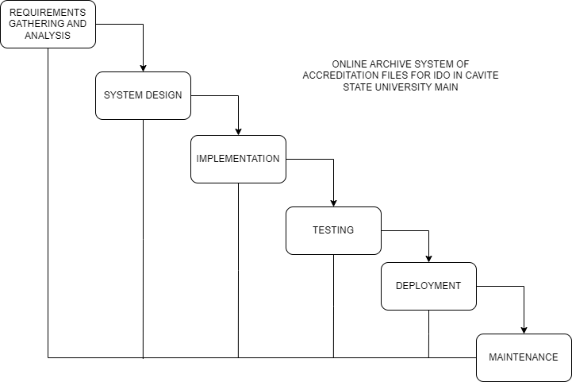

**Conceptual Framework.** The graphical representation below (Figure 1) is an Input-Process-Output (IPO) model, a popular approach for describing the structure of an information processing program or another process in systems analysis and software engineering (Braunschweig, 2018), used as the conceptual framework for this study. It depicts the whole procedure of the study wherein the Input section consists of knowledge, software and hardware requirements needed for the development of the system. In the Process section, the materials from the Input are used for the design and development, in which the output will be this study.

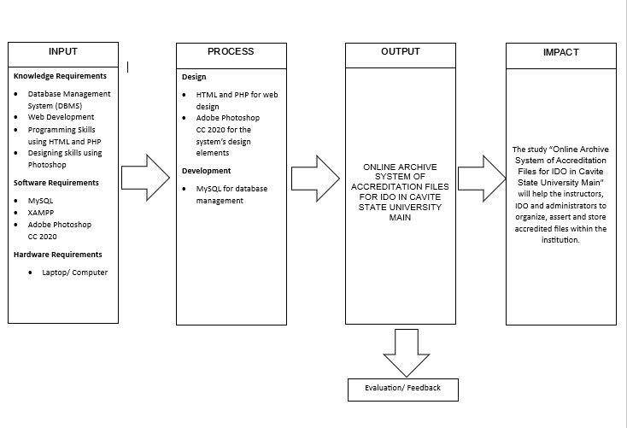

Figure 2. Conceptual Framework for the study Online Archive System of Accreditation Files in Cavite State University Main

**Systems Architecture.**  This study will have modules that serve as the overview of the functions developed in the system, which is the CvSU Archive System. These modules will consist of all the features that can be found in the system. The system will be composed of three different modules, which are the account management module, document management module, and log management module. Each module has different features that have their own functions.

*Account Management Module.* This module includes handling of the records of accounts that are registered on the system. These registered accounts are classified according to their level of authorization. It needs a valid CvSU email address belonging to the members of the university to verify if the specific person can access the system. The features of the system to be interacted with by users will depend on the level of user access. If the level of access is of general CvSU members, the features that will be available to the user would only be limited to downloading and viewing of documents. Next is the IDO staff, they will have access to the features available to CvSU members as well as uploading, updating, and deleting of files. Lastly, the administrator has the ability to oversee and monitor the system as well as the interactions happening within.

*Document Management Module.* The users will be able to access files in terms of viewing, uploading, downloading, and sharing of files, however, CvSU members are not permitted to upload, update, and delete files. The IDO staff will have the right to upload, view, download, share, and delete documents including accreditation files. The administrator will not just be able to upload, view, download, and share files, but delete them as well. Furthermore, the files in the system are categorized according to the areas used for accreditation and shall be organized by the type of file.

*Log Management Module.* This module is responsible for the continuous process of collecting, parsing, storing, analyzing, and disposing of data which includes specific timestamps of the users’ logging in or out. It also holds the records of the users who upload and download files, along with the deletion of certain documents done by the administrator. Lastly, the administrator can access all the features previously mentioned along with the system’s logs.

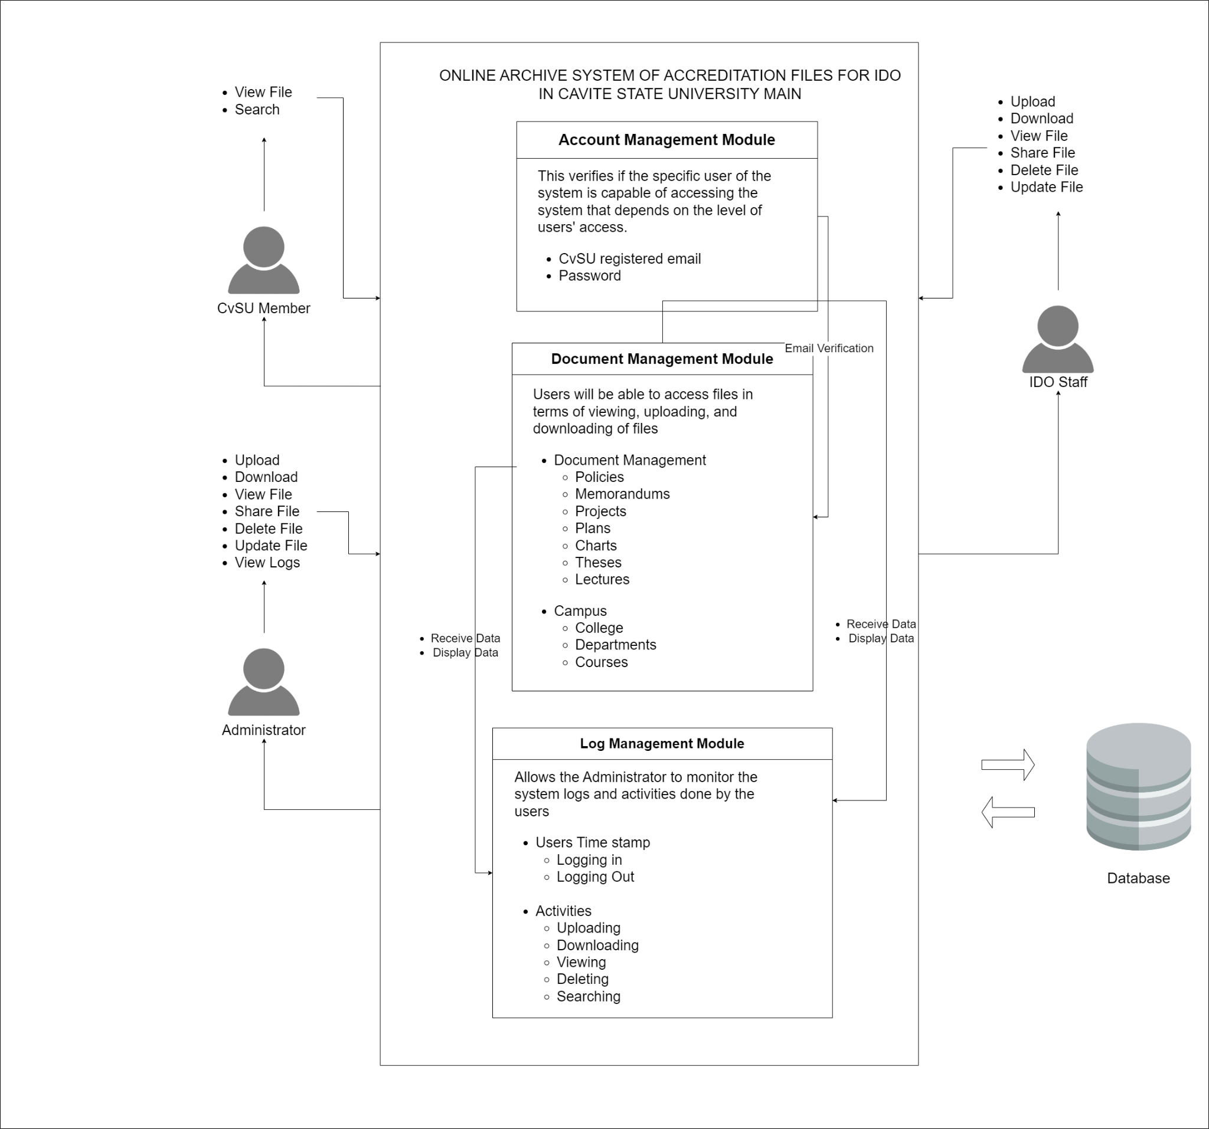

Figure 3. Systems Architecture for the study Online Archive System of Accreditation Files in Cavite State University Main

Table 2. System Requirements for the Proposed System

|  |  |  |
| --- | --- | --- |
| **HARDWARE** | **SOFTWARE** | **PEOPLEWARE** |
| Laptop or Desktop with at least 4 GB RAM | Windows 7 and up/MacOS X 10.9 and up  Web browsers such as Google Chrome, Firefox, Safari, Opera, and Microsoft Edge | CvSU members such as students and instructors, IDO staff, and administrators of Cavite State University |

The researchers chose computers as the platform in using the system since these are commonly used in this era. Computer desktops or laptops are frequently used for educational purposes and can be used for long periods of time.

*Windows* or *MacOS* as the operating system for desktops and laptops. It is important to use the specified versions on the table above since it is the minimum requirement for the current year. It also assures the researchers that the device is capable of using the developed system.

Widely used web browsers such as Google Chrome, Firefox, Safari, Opera, and Microsoft Edge are to be used as applications to access the proposed system since it is to be available with only the use of the Internet. For the system to be able to display the correct components and function as intended, the use of any of the web browsers is required along with the connection to the Internet as it is imperative for without the use of Internet, the system won’t be accessible regardless of the system requirements a user currently has. A user should have at least one of the required hardware, an operating system, and a web browser to ensure that the system will work properly.

# **Development and Testing**

**UML Tools.** The diagrams used to describe the flow of the system (Appendix Figure 1, 2, and 3), which are use case diagrams, a method of system analysis that is used to system requirements should be identified, clarified, and organized (Aleryani, 2016, p.124). Appendix Figure 1 describes the activities of the system associated with the instructors in this study, Appendix Figure 2 illustrates the functions of the system interactable by the IDO staff, and lastly, Appendix Figure 3 exhibits the functionalities of the system that the administrators can access.

**ISO testing.** This program was developed in accordance with the ISO/IEC 9126 quality model to test its specifications, which mainly focuses on the criteria to test the specification of the developing program.

To ensure that the system is working properly, it must meet the following:

Table 3. ISO/IEC 9126 testing method used for the study.

|  |  |
| --- | --- |
| **FUNCTIONALITY** | * Display the correct buttons. * Record the user’s inputs. * Display the user inputs from the search bar. * View, delete, download, upload, and share files based on the user's level of access. * Sort and organize files that are being uploaded. |
| **USABILITY** | * Easy to navigate and understand. * Display buttons with appropriate functions. * Engaging system design. * System provides the files based on what the user needs. |
| **RELIABILITY** | * Error messages are displayed when an error occurs. * System is user-friendly. * Record the user’s data who is accessing the system. |
| **EFFICIENCY** | * The pages shall load 3-5 seconds based on the user’s connectivity. * When a button is clicked, the system shall display the correct function. |
| **MAINTAINABILITY** | * Errors and bugs are to be identified and recorded. * The system shall still work as intended with new updates applied. |
| **PORTABILITY** | * The system can be opened through a computer using the Internet. |

**Data Analysis Plan.** To evaluate and organize the result of the proposed system, the Statistical Treatment of Data Analysis is used, specifically, the two methods of statistical analysis which are mean, and standard deviation, for the assessment of the participants. Below are the formulae for the statistical analysis methods.

1. Mean

$$̅\overline{x}=\frac{\sum_{i=1}^{n}{x_{i}}}{n}$$

Where,

$\overline{x}$ = mean

$\sum_{i=1}^{n}{x_{i}}$ = sum of all terms

$n$ = total number of participants

1. Standard Deviation

$$σ=\frac{\sqrt{\sum_{i=1}^{n}{{\left(\overline{x}-x_{i}\right)}^{2}}}}{N}$$

Where,

$σ$ = population of standard deviation

$x_{i}$ = each value of the population

$\overline{x}$ = population mean

$N$ = size of the population

**Unit Testing.** This level of testing includes analyzing and testing the individual elements of the system based on different modules. The researchers will check if specific functions are working properly and identify errors from within to be able to debug after the preliminary testing before moving forward to test how functions work with each other.

**Integration Testing**. This level of testing checks the accuracy of interaction between various system modules and its expected outcome. The researchers shall make sure that each module does not collide with one another. Each tested module must display in the interface the appropriate function. Additionally, requirements are frequently updated, and new pieces of code are added. Once the needed requirements are updated, the system will be tested again.

**System Testing.**  In this level of testing, it analyzes the fully integrated tested system after the integration testing where codes are being updated and well tested. This phase will provide the system overview since tests were done and there should be no worries for crashing of the system and other unnecessary errors in the system.

**Acceptance Testing.** In this phase of testing, the researchers will check if the system met the requirements as stated in the study, allowing the users to test the system themselves and provide feedback that will help the researchers for maintenance purposes and updates of the system. This shall give light for the researchers to improve the functionality of the system and ensure that the system works as intended.

**REFERENCES**

Aleryani, A. Y. (2016, January 4). Comparative study between data flow diagram and use case diagram. *International Journal of Scientific and Research Publications, 6*(3), 124-126.

Al Shobaki, M. J., S Abu Naser, S. S., & Kassab, M. K. I. (2017, January). The Reality of the Application of Electronic Document Management System in Governmental Institutions -an Empirical Study on the Palestinian Pension Agency. *International Journal of Engineering and Information Systems, 1*(2). 1-14.

Ambat, A., & Javier, M. (2017). Record Management System of Quality Assurance and Accreditation Center in Cavite State University.

Bell, D. (2003). UML basics: An introduction to the Unified Modeling Language. *The Rational Edge*.

Braunschweig, D. (2018, December 15). Input-Process-Output Model. Programming Fundamentals. *Rebus Community*.

Caluza L, (2019, July). Development of Electronic Document Archive Management System (EDAMS): A Case Study of a University Registrar in the Philippines. *International Journal of Digital Information and Wireless Communications (IJDIWC), 7*(2). 106-111.

Cuevas L., et al (2022, June 6). Electronic Document Archival System of STO. Niño National High School. *International Journal of Scientific and Management Research, 5*(6). 2-5.

De Castro J. (2014) Centralized Repository of Accreditation Files in College of Engineering and Information Technology. 1-6.

Dr. Khojah, A. & Dr. Shousha, A. (2020, April 25). Academic Accreditation Process of English Language Institute: Challenges and Rewards. *Canadian Center of Science and Education, 10*(2). 176-188.

Estrera, P. J. M. (2017, May). Electronic Document Management System for Higher Education Institution. *International Journal of Innovative Science and Research Technology, 2*(5). 549-556.

Gupton, L. M. (2021). The Pros and Cons of Digital vs. Printed Documents. *Staples®*.

Herwahyudi, R., Permana, R., Rohmat, D., Hadi, M. B., & Zakiah, A. (2020, December 25). E-archive Application Based on Web (Case Study: PT Digantara Indonesia (PERSERO)). *Palarch’s Journal Of Archaeology Of Egypt/Egyptology. 63*(5). 3-8.

Hou, A. Y. C., Kuo, C. Y., Chen, K. H. J., Hill, C., Lin, S. R., Chih, J. C. C., & Chou, H. C. (2018, December 16). The implementation of self-accreditation policy in Taiwan higher education and its challenges to university internal quality assurance capacity building. *Quality in Higher Education, 24*(3). 238-259.

Ismail, S. N. (2013). Thesis Project Archive System (T-PAS). 1-32.

Las Johansen, B. C. (2017, January 1). Development of Electronic Document Archive Management System (EDAMS): A Case Study of a University Registrar in the Philippines. *International Journal of Digital Information and Wireless Communications (IJDIWC), 7*(2). 106-117.

Nora, L. M. (2022, January). Using Accreditation to Transform Diversity, Equity, and Inclusion Efforts Into Diversity, Equity, and Inclusion Systems. *Academic Medicine, 97*(1). 25-29.

O’Brien, J. and Marakas, G. M. (2021, September 26). Management Information Systems.

Oktarina, N., Widodo, J., Murwatiningsih, M., & Murniawaty, I. (2019, July, 3). Electronic Agenda (E-Agenda) Systems for Keeping School Archives in Indonesia: Is There A Case in Managing of Archive through Manual Agenda System?

PAASCU (2021, February). Handbook on Accreditation. *PHILIPPINE ACCREDITING ASSOCIATION OF SCHOOLS, COLLEGES AND UNIVERSITIES.* 1-36.

Suharti, S., Akib, H., Jamaluddin, J., & Thukiman, K. (2020, May 1). Archive Management Analysis in Secondary School. *International Journal of Educational Administration, Management, and Leadership*. 1-6.

Taib, A. M., Shukri, N. A. M., Zukri, N. H. A., & Ghazali, N. (2020, October 15). Smart Final Year Project Archive System Using Laravel Framework with Email Notification (SFYPAS). *Journal of Computing Research and Innovation, 5*(2). 41-53.

**APPENDICES**

# **APPENDIX 1**

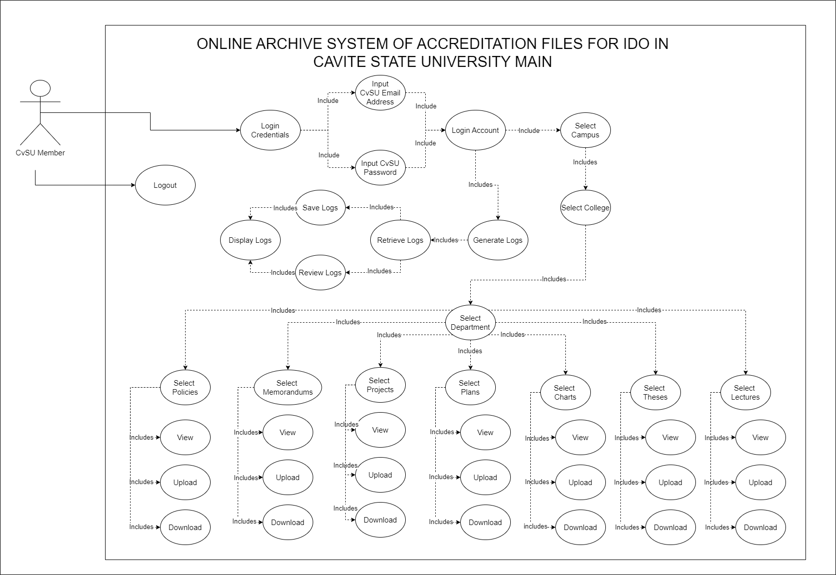Appendix Figure 1. Use Case Diagram of the Instructor for the study Online Archive System of Accreditation Files in Cavite State University Main

# **APPENDIX 2**

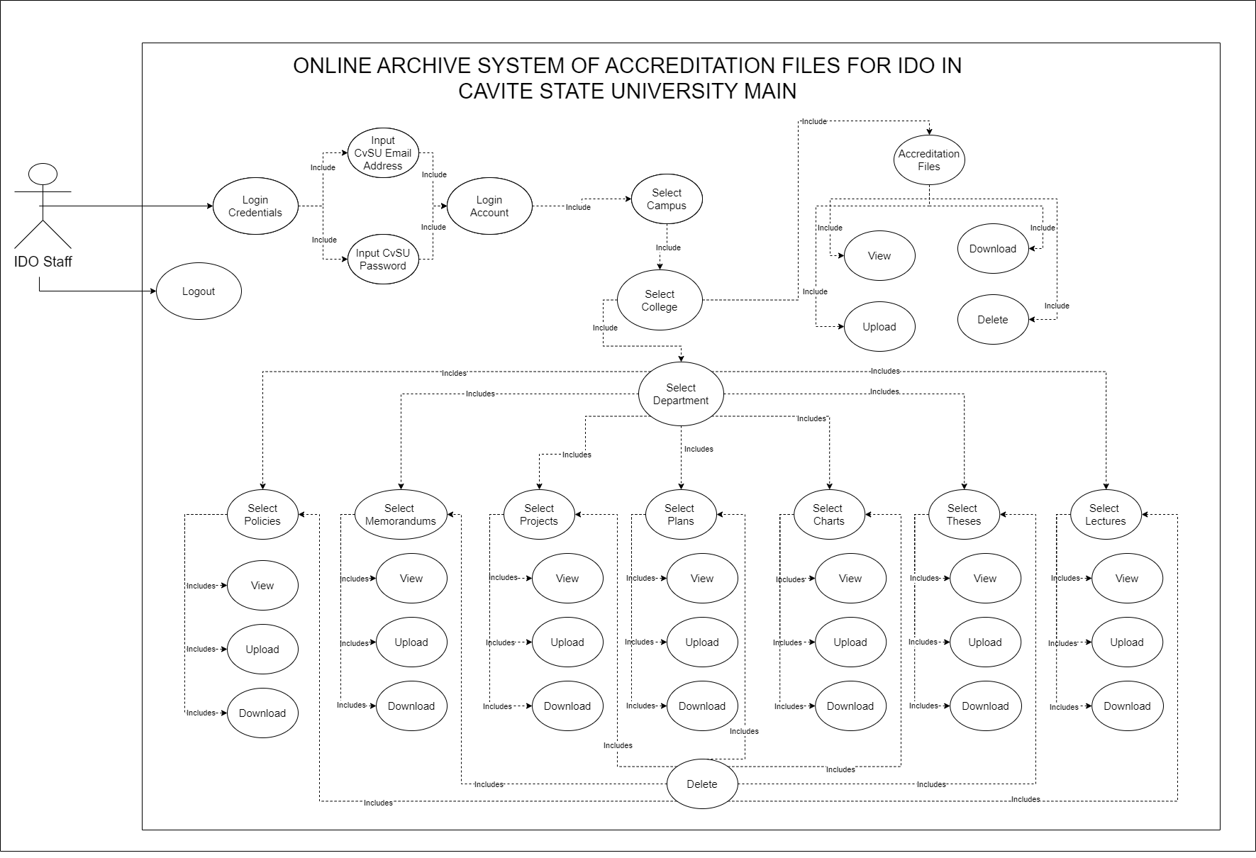 Appendix Figure 2. Use Case Diagram of the IDO Staff for the study Online Archive System of Accreditation Files for IDO in Cavite State University Main

# **APPENDIX 3**

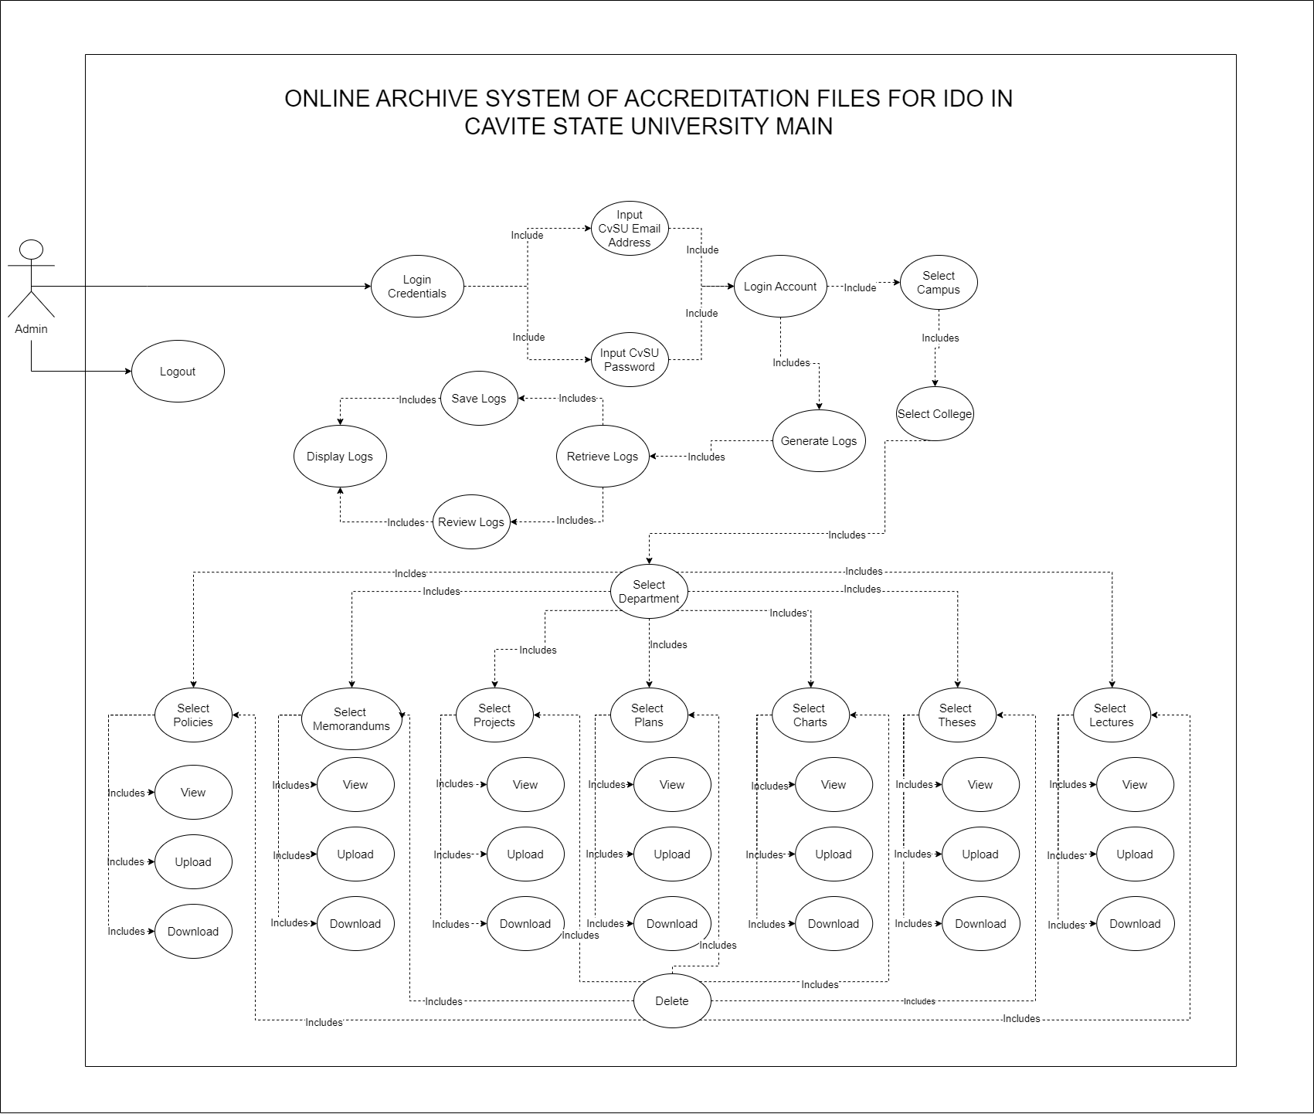

Appendix Figure 3. Use Case Diagram of the Administrator for the study Online Archive System of Accreditation Files in Cavite State University Main